**Northern long-eared bat (NLEB)**

link to Programmatic Biological Opinion <https://connect.ncdot.gov/resources/Environmental/EAU/BSG/Documents/Bats/Bat%20Programmatics%20(Div%201-8)/20221215_PBO_Revised_NLEB_Divisions1-8.pdf>

**To be included in NRTRs and NEPA/SEPA Documentation for projects in Divisions 1-8.**

The US Fish and Wildlife Service has issued a programmatic biological opinion (PBO) in conjunction with the Federal Highway Administration (FHWA), the US Army Corps of Engineers (USACE), and NCDOT for the northern long-eared bat (NLEB) (*Myotis septentrionalis*) in eastern North Carolina.  The PBO covers the entire NCDOT program in Divisions 1-8, including all NCDOT projects and activities.  Although this programmatic covers Divisions 1-8, The USFWS only considers NLEBs to be known or potentially found in 30 counties within Divisions 1-8 (Figure 2, PBO). NCDOT, FHWA, and USACE have agreed to conservation measures which will avoid/minimize mortality of NLEBs.  The programmatic determination for NLEB for the NCDOT program is **May Affect, Likely to Adversely Affect**. The PBO will ensure compliance with Section 7 of the Endangered Species Act for ten years (effective through December 31, 2030) for all NCDOT projects with a federal nexus in Divisions 1-8, which includes [*XXXX* C*ounty*] , where [PROJECT #] is located.

**ECAP or Division Environmental Staff will evaluate and include the following bulleted list in Project Commitments (Green Sheets) for projects in Divisions 1-8**

**NLEB***:*

* NCDOT has agreed to avoid tree clearing* within 150 feet of known maternity roost trees during the time frame of May 1 – June 30, thus reducing the probability of killing non-volant young. Winter roost trees are *not* considered maternity roost trees. The Eastern NC Protected Bat Maternity Roosts are identified [here](https://ncdot.maps.arcgis.com/apps/mapviewer/index.html?webmap=0a61ee1304f747afa4265835bb6b2743) (NCDOT Biological Surveys Connect site <https://connect.ncdot.gov/resources/Environmental/EAU/BSG/Pages/default.aspx>).
* At individual projects where a total of 1.0 acre or more of tree clearing will occur, no tree clearing will occur during the portion of the day that the air temperature is <40 degrees F in order to protect NLEBs that may be in torpor. This restriction is only subject to the known/potential range (30 coastal counties) that is shown in Figure 2 below†.

* tree clearing is considered removing trees. Clearing limbs along the ROW is not considered ‘clearing’.

* In order to monitor the impacts of incidental take, the NCDOT must report the progress of the Action and its impact on the species to the Service as specified in the ITS (50 CFR §402.14(i)(3)). Specific instructions for such monitoring and reporting (M&R) are listed below. These M&R requirements are mandatory.
* If dead bats suspected of being NLEB are observed during clearing, demolition, or construction activities of the Action, such bats should be collected and preserved for identification. Gary Jordan of the Service’s Raleigh Field Office should be contacted at [gary_jordan@fws.gov](mailto:gary_jordan@fws.gov) to arrange a transfer of the bats. Dead bats should be placed in a freezer until they can be transferred.
* NCDOT staff and/or consultants must follow the NCDOT Bat Habitat Assessment SOP by filling out Bat Habitat Assessment Forms for projects that affect bridges and culverts. These forms will be submitted to the NCDOT Biological Surveys Group and entered into its database even if no bat presence is detected. If NLEBs are detected at a bridge or culvert, the Service will be notified via email at [gary_jordan@fws.gov](mailto:gary_jordan@fws.gov).

Note: Reporting of tree clearing is no longer required.

The Eastern NC Protected Bat Maternity Roosts map is kept up to date with known maternity roost locations so you can check your projects (there are no known TCB mat roosts at this time, only NLEB)…the map link is on our Connect site [**here**](https://gcc02.safelinks.protection.outlook.com/?url=https%3A%2F%2Fncdot.maps.arcgis.com%2Fapps%2Fmapviewer%2Findex.html%3Fwebmap%3D0a61ee1304f747afa4265835bb6b2743&data=05%7C02%7Cclknepp%40ncdot.gov%7C5c07406e68fa447380a808dd19688652%7C7a7681dcb9d0449a85c3ecc26cd7ed19%7C0%7C0%7C638694658906291580%7CUnknown%7CTWFpbGZsb3d8eyJFbXB0eU1hcGkiOnRydWUsIlYiOiIwLjAuMDAwMCIsIlAiOiJXaW4zMiIsIkFOIjoiTWFpbCIsIldUIjoyfQ%3D%3D%7C0%7C%7C%7C&sdata=%2FvPadvcw9DNOjYg3RZT%2FRbbVZRJlO5ydM8sIWUh7PN8%3D&reserved=0) and screenshot location on Connect below:

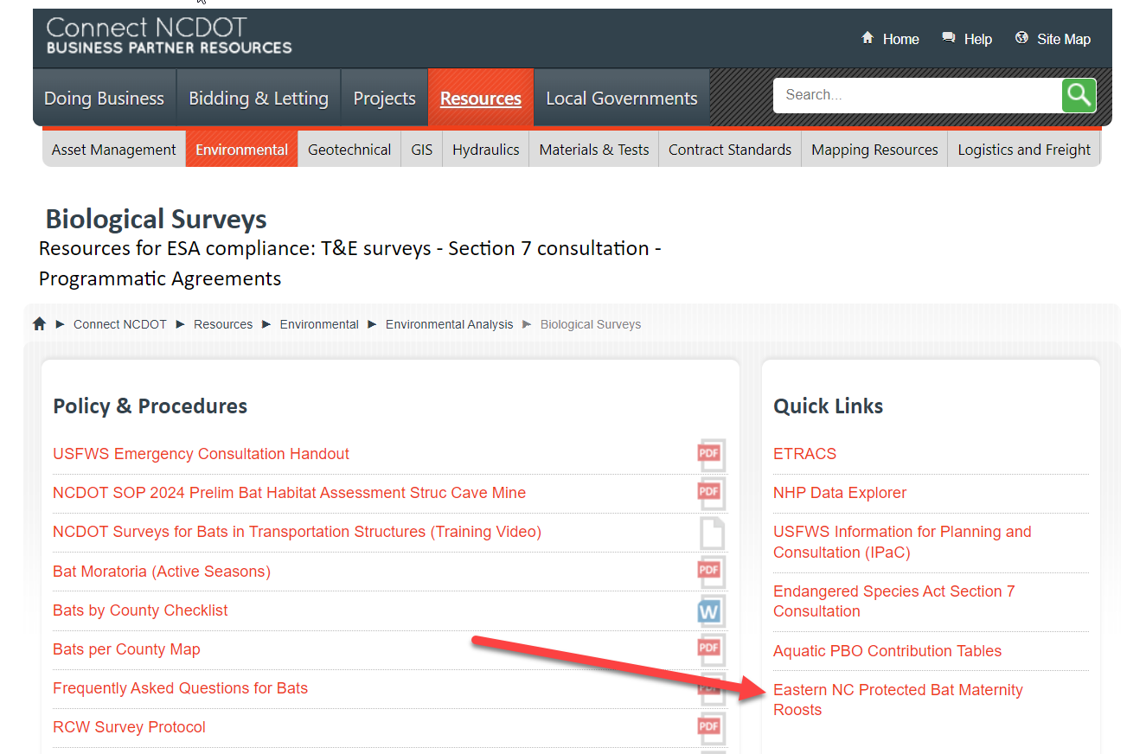

† - The tree clearing temperature threshold <40**°**F, only applies to the 30 current known/potential NLEB counties shown in Figure 2 of the PBO (pasted below for your convenience).

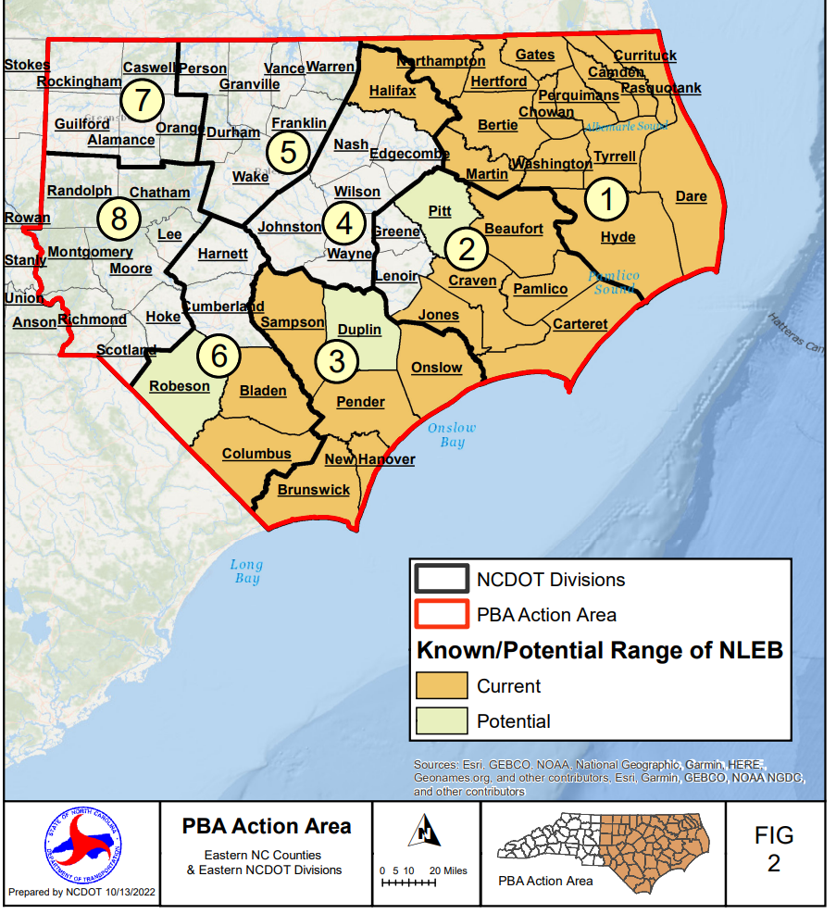

**Tricolored bat (TCB)**

Link to Programmatic Conference Opinion <https://connect.ncdot.gov/resources/Environmental/EAU/BSG/Documents/Bats/Bat%20Programmatics%20(Div%201-8)/20231120_PCO_signed_TCB_programmatic.pdf>

**To be included in NRTRs and NEPA/SEPA Documentation for projects in Divisions 1-8.**

The US Fish and Wildlife Service has issued a programmatic conference opinion (PCO) in conjunction with the Federal Highway Administration (FHWA), the US Army Corps of Engineers (USACE), and NCDOT for the tricolored bat (TCB) (*Perimyotis subflavus*) in eastern North Carolina.  The PCO covers the entire NCDOT program in Divisions 1-8, including all NCDOT projects and activities.  NCDOT, FHWA, and USACE have agreed to conservation measures which will avoid/minimize take to TCBs.  These conservation measures apply to all counties in Divisions 1-8.  The programmatic determination for TCB for the NCDOT program is **May Affect, Likely to Adversely Affect**. Once the TCB is officially listed, the PCO will become the programmatic biological opinion (PBO) by formal request from FHWA and USACE. The PBO will ensure compliance with Section 7 of the Endangered Species Act for approximately five years (effective through December 31, 2028) for all NCDOT projects with a federal nexus in Divisions 1-8, which includes [*XXXX* C*ounty*] , where [PROJECT #] is located.

**ECAP or Division Environmental Staff will evaluate and include the following bulleted list in Project Commitments (Green Sheets) for projects in Divisions 1-8**

**TCB***:*

* No tree clearing* will occur within 150 feet of a known maternity roost tree May 1 – July 15 in order to protect non-volant young. Winter roost trees are not considered maternity roost trees. NCDOT will cross-reference information provided by the Service for locations of maternity roosts*.*

* tree clearing is considered removing trees. Clearing limbs along the ROW is not considered ‘clearing’

Note: At this time, no TCB maternity roost trees have been identified in Div 1-8.

* In order to monitor the impacts of incidental take, the NCDOT must report the progress of the Action and its impact on the species to the Service as specified in the ITS (50 CFR §402.14(i)(3)). Specific instruction for such monitoring and reporting (M&R) are listed below. These M&R requirements are mandatory.
* If dead bats suspected of being TCB are observed during clearing, demolition, or construction activities of the Action, such bats should be collected and preserved for identification. Gary Jordan of the Service’s Raleigh Field Office should be contacted at [gary_jordan@fws.gov](mailto:gary_jordan@fws.gov) to arrange a transfer of the bats. Dead bats should be placed in a freezer until they can be transferred.
* Structure bat surveys will be performed during the Natural Resource Technical Report phase of projects that are to replace a bridge or culvert > 5 feet in diameter. This information will then be recorded in NCDOT’s database on bridges and culverts. NCDOT staff and/or consultants must follow the NCDOT Bat Habitat Assessment SOP by filling out Bat Habitat Assessment Forms for projects that affect bridges and culverts. These forms will be submitted to the NCDOT Biological Surveys Group and entered into its database even if no bat presence is detected. If TCBs are detected at a bridge or culvert, the Service will be notified via email at [gary_jordan@fws.gov](mailto:gary_jordan@fws.gov).